PACMAN se-071 syeda moneebah

INTRODUCTION

Pacman is a well knows 90s game that first took off in arcades where simple games would be played. This arcade game was one of its kind and some might go so far as to say it is the most iconic arcade game ever.

For me, I wanted to recreate this childhood game which I spent hours upon hours playing when I was a kid. Not once in my gaming journey did, I ever think about how this game was actually coded. Thus, now that I equipped myself with python and pygame knowledge I set forth to code this game

objective

You have to collect all the coins without getting caught by the enemies. Each time you collect a coin, your score goes up by one. Collect all the coins to win the game and get high scores along the way. Note that if you get caught by a ghost/enemy you will lose 10 points! You will also lose a life. You only have 3 tries to make a high score after that, GAME OVER!

INTERFACE

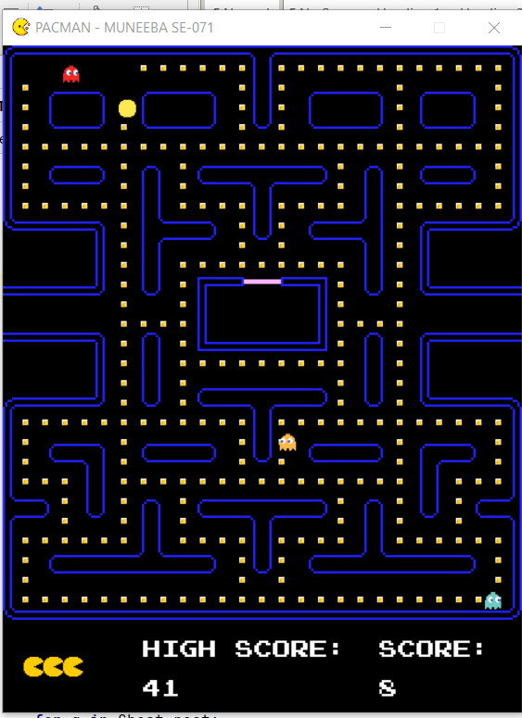

Code mechanism

1. I first imported all the libraries, modules, images and assets I would need for my program and set up my main window that would hold my code 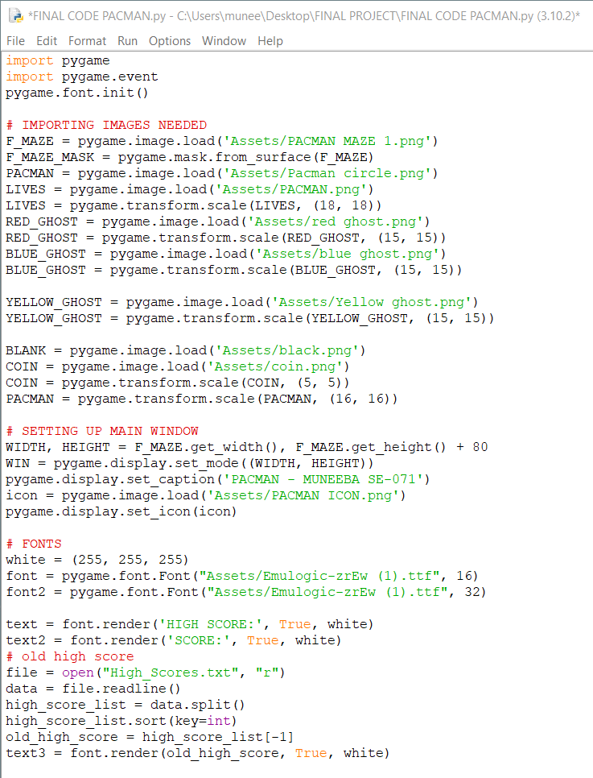
2. I then set up the fonts to be displayed and opened the file to display the previous high score

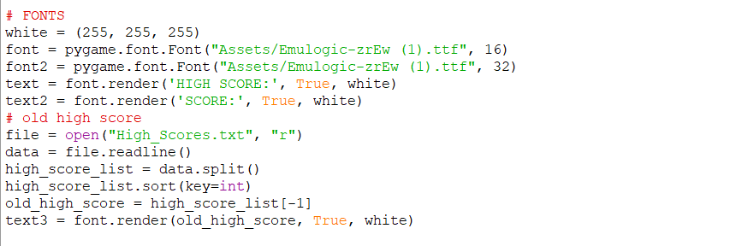

1. Next are some of the functions to be used in the code like
2. drawing the elements,
3. making a mask for the maze and player in order to detect collision,
4. changing to the next point so that ghosts may move accordingly

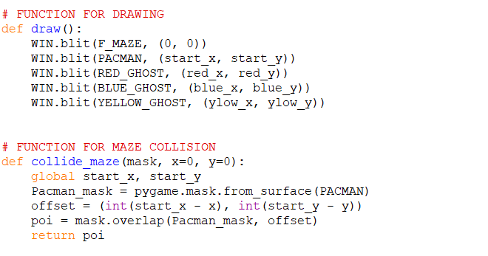

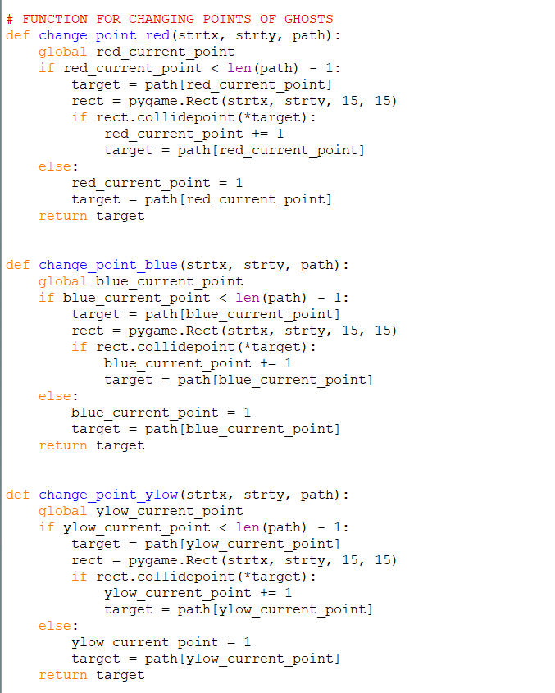

4. The variables are initialized and the Maze array is created to help with certain features later on

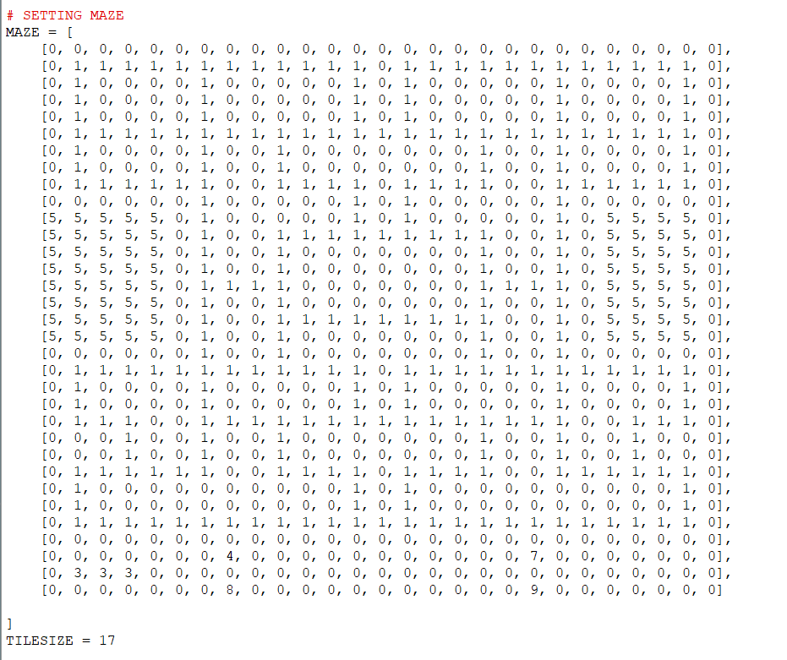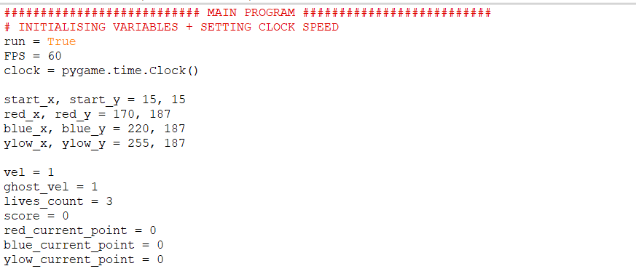

5. This is the list of point that certain ghosts/enemies will follow in order to fully cover the maze;

Red tends to stay towards the upper, Yellow in the middle and blue circles the bottom

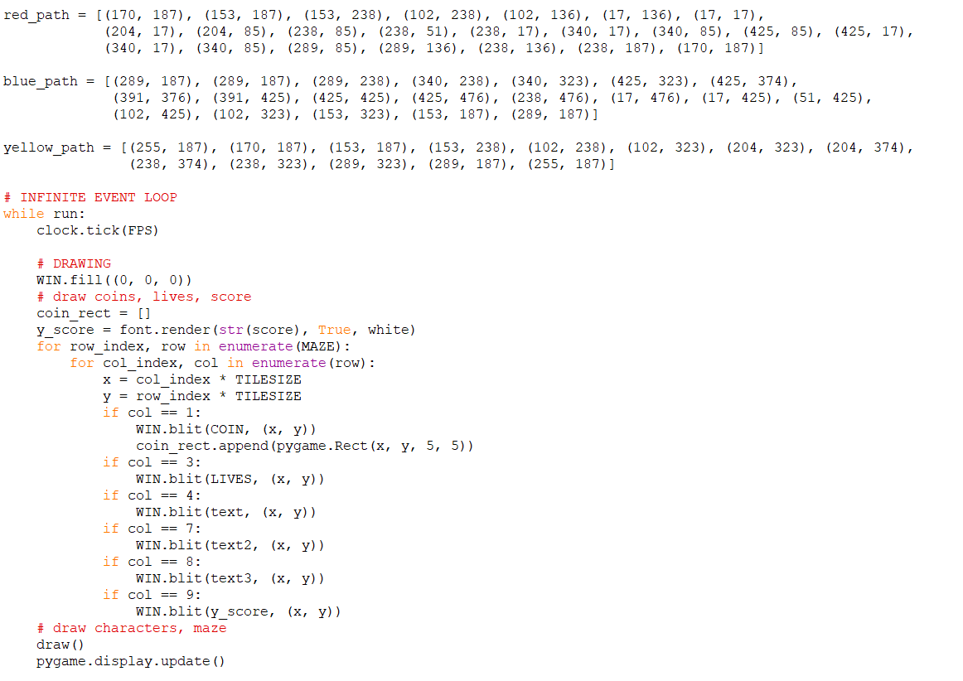

1. This is the infinite event loop that checks for key presses, and basically where the code takes place. I set a clock speed so all players on all computers have the same speed of Pacman. The first thing to do is draw characters: pacman, ghosts/enemies, coins to collect

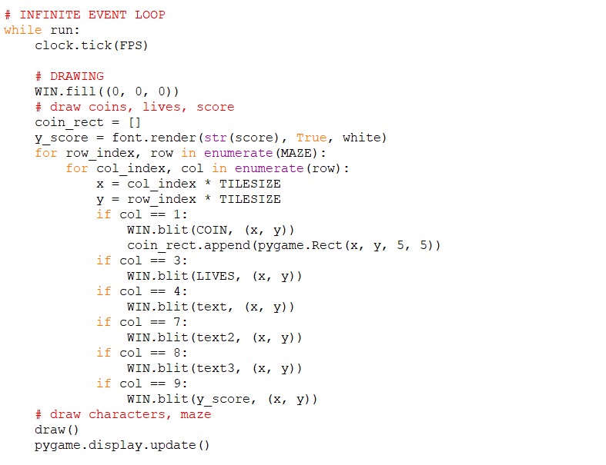

1. The mechanism for making the ghosts/ enemies move across the screen is below:

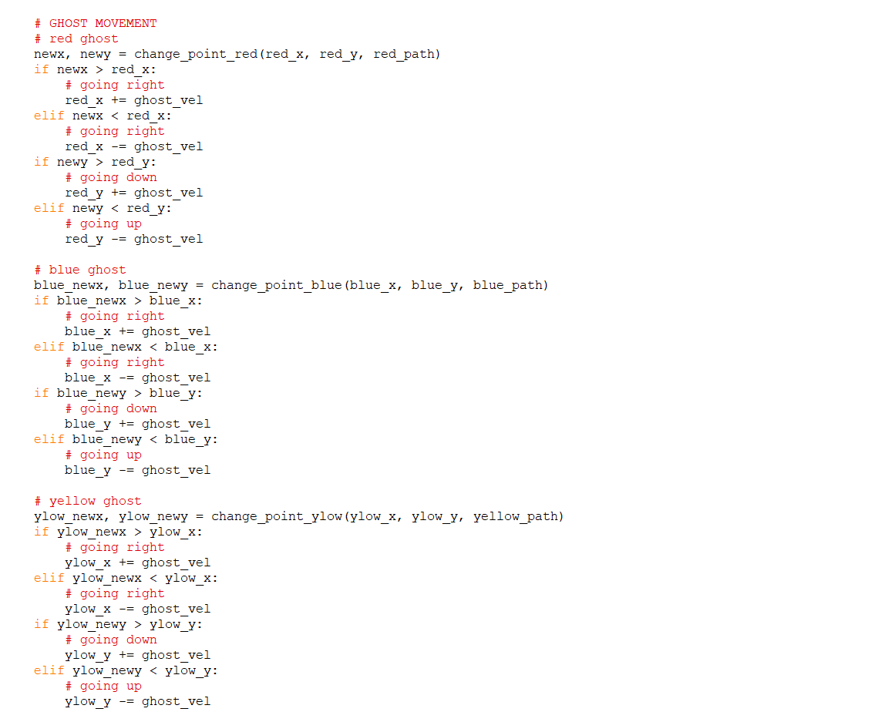

1. Maze collision first checks whether pacman collided with the maze and then it adjusts the player so that Pacman can’t enter certain areas

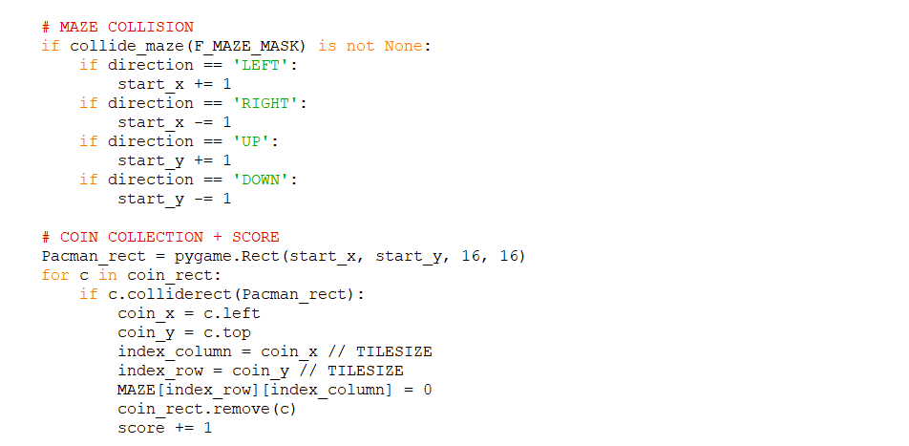

1. This part adjusts the array according to how many coins get collected it sets an empty space whenever Pacman collects a coin (using rectangles to identify this) and increases one point. This part of the code also sets the high score if you were to get all coins without ever getting caught by a ghost/enemy

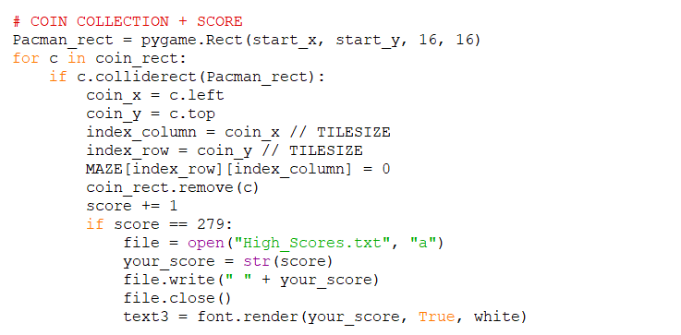

1. Ghost/Enemy collision is important as the player then gets a life removed (have a total of 3 lives) this part of the code minuses 10 point if you get hit by a Ghost
2. This part of the code is also responsible for adjusting the high score if you lose all your lives. It checks if your high score beat the old score and adjusts accordingly

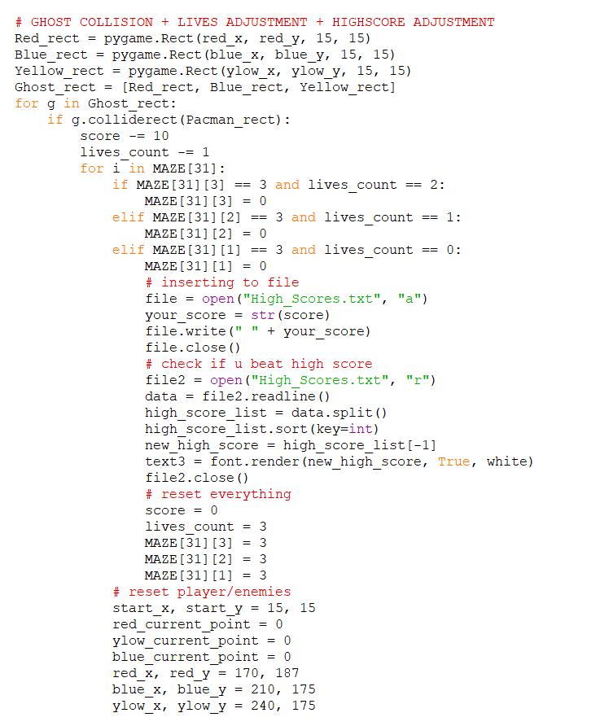

1. This part detects your key presses and moves Pacman according and it even check for the event of closing the screen and then exits the infinite loop and closes the game

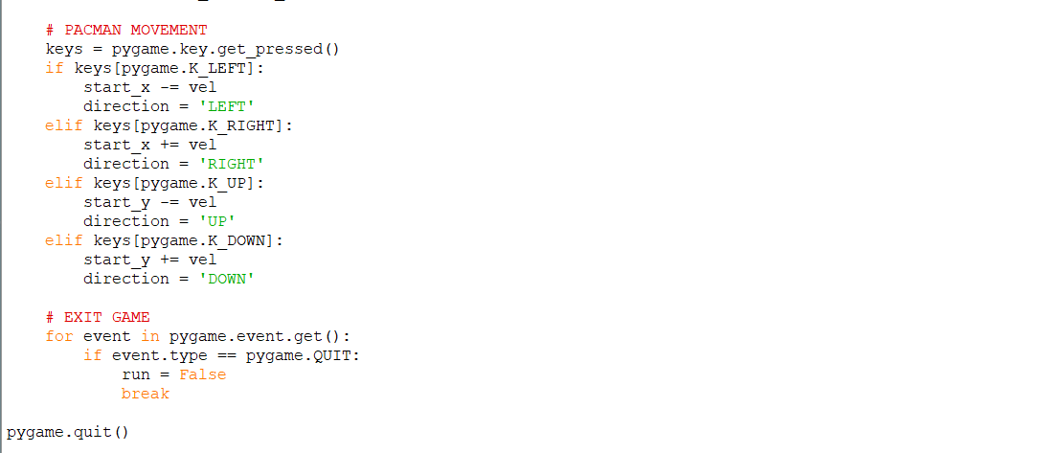

se-071 syeda moneebah